

Hello, my name is Mrs. McKenzie. I am so excited to be working your child nd this year in the subject areas of EIP Reading and/or EIP Math in grades 4th & 5th. I hope that you have enjoyed your summer break, and now you’re ready to learn. I firmly believe in the saying that “it takes a village” to educate our children. With that being said, I look forward with working with you, your child, and you child’s teacher to ensure that he/she has a successful academic school year.

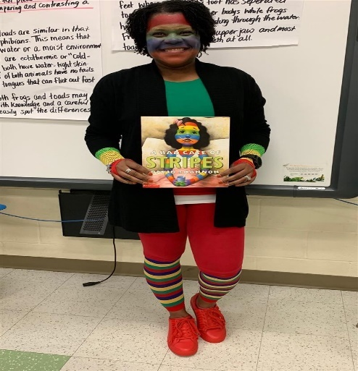 About Me:

Birthday: August 1st

Colors: black, peridot green, & red

Snacks: Tom’s Salt & Vinegar Chips, & Mrs. Vickie’s BBQ chips

Book: *I Am Enough*

Drinks: water, Starbucks Vanilla Bean, & Starbucks Caramel Ribbon Crunch

Hobbies: crafting & riding my bike

Things to Do: traveling, spending time with my family, &

**dancing**

What is EIP?

The Early Invention Program (EIP) is designed to serve students in kindergarten through grade five who are at risk of not reaching or maintaining academic grade level. Its purpose is to provide additional instructional resources to help students who are performing below grade level obtain the necessary skills to reach each grade level performance in the shortest possible time.

Reading Focus:

We will be using grade level appropriate resources to enhance phonics, fluency, vocabulary, & comprehension skills to help increase and/or obtain grade level. Students will also be expected to create the following types of writings: narrative, informational, and persuasive.

Math Focus:

We will be using grade level appropriate resources to build fact fluency (addition, subtraction, multiplication, and division) and to increase numeracy. Students will also be expected to comprehend word problems (read, model (show work), and solve).

Classroom Expectations

All students should come to class prepared (with paper, pencil, & laptop), ready to learn, and be an active participant. Students are expected to follow all classroom and school rules at all times. I will track all student behavior using ClassDojo. Please make sure you use the class code below follow your child’s behavior.

4th Grade Class Code:

5th Grade Class Code:

Contact Information

Mrs. McKenzie

706-796-4918

[mckenta@boe.richmond.k12.ga.us](mailto:mckenta@boe.richmond.k12.ga.us)

or via ClassDojo